**Revisión de Conocimientos Previos**

**Diagrama de topología**

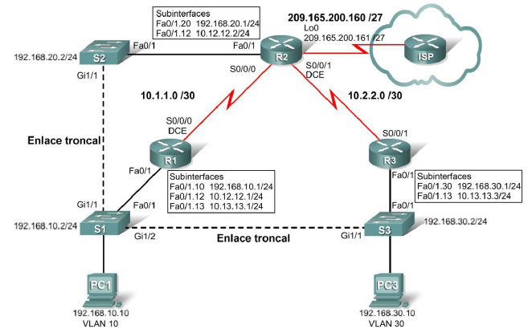

**Tabla de direccionamiento**

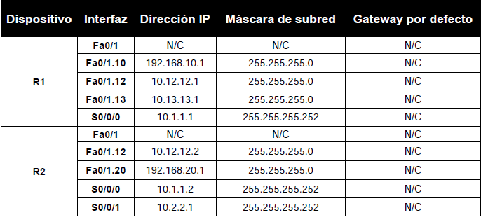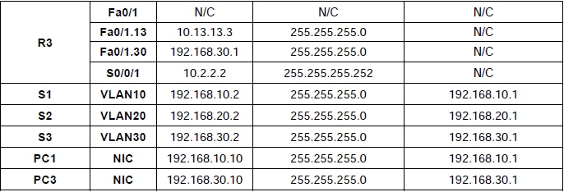

**Objetivos de aprendizaje**

Para completar esta práctica de laboratorio:

∙ Realizar tareas de configuración básicas en un router

∙ Configurar y activar interfaces

∙ Configurar el protocolo Spanning Tree

∙ Configurar las VLAN en los switches

∙ Configurar Trunks entre los dispositivos

∙ Configurar el enrutamiento OSPF en todos los routers

**Tarea 1: Realizar las configuraciones básicas de dispositivos**

Configure los routers R1, R2 y R3, y los switches S1, S2 y S3 de acuerdo con las siguientes instrucciones:

∙ Configure el nombre de host.

∙ Deshabilite la búsqueda DNS.

∙ Configure una contraseña de Modo EXEC.

∙ Configure un mensaje del día.

∙ Configure una contraseña para las conexiones de la consola.

∙ Configure el registro de datos sincrónico.

∙ Configure una contraseña para las conexiones de vty.

**Tarea 1: Realizar las configuraciones básicas de dispositivos**

***Ejemplo para R1***

enable

configure terminal

Configure el nombre de host.

hostname R1

Deshabilite la búsqueda DNS

no ip domain-lookup

Configure una contraseña de Modo EXEC

enable secret class

Configure un mensaje del día

banner motd ^CUnauthorized access strictly prohibited and prosecuted

to the full extent of the law^C

Configure una contraseña para las conexiones de la consola.

line con 0

exec-timeout 0 0

Configure el registro de datos sincrónico.

logging synchronous

password cisco

login

Configure una contraseña para las conexiones de vty

line vty 0 4

password cisco

login

end

Guarde la configuración actual

copy running-config startup-config

**Repita los pasos para el resto de los dispositivos**

**Tarea 2: Configurar y activar las direcciones serial y Ethernet**

**Paso 1: Configurar las interfaces de R1, R2 y R3.**

**R1**

!

interface FastEthernet0/1

no ip address

no shutdown

!

interface FastEthernet0/1.10

encapsulation dot1Q 10

ip address 192.168.10.1 255.255.255.0

!

interface FastEthernet0/1.12

encapsulation dot1Q 12

ip address 10.12.12.1 255.255.255.0

!

interface FastEthernet0/1.13

encapsulation dot1Q 13

ip address 10.13.13.1 255.255.255.0

!

interface Serial0/0/0

ip address 10.1.1.1 255.255.255.252

no shutdown

clock rate 64000

!

**R2**

!

interface FastEthernet0/1

no ip address

no shutdown

!

interface FastEthernet0/1.12

encapsulation dot1Q 12

ip address 10.12.12.2 255.255.255.0

no snmp trap link-status

!

interface FastEthernet0/1.20

encapsulation dot1Q 20

ip address 192.168.20.1 255.255.255.0

no snmp trap link-status

!

interface Serial0/0/0

ip address 10.1.1.2 255.255.255.252

no shutdown

!

interface Serial0/0/1

ip address 10.2.2.1 255.255.255.252

clock rate 64000

no shutdown

**R3**

interface FastEthernet0/1

no ip address

no shutdown

!

interface FastEthernet0/1.13

encapsulation dot1Q 13

ip address 10.13.13.3 255.255.255.0

!

interface FastEthernet0/1.30

encapsulation dot1Q 30

ip address 192.168.30.1 255.255.255.0

!

interface Serial0/0/1

ip address 10.2.2.2 255.255.255.252

no shutdown

**Paso 2: Verificar el direccionamiento IP y las interfaces.**

R1#**show ip interface brief**

Interface IP-Address OK? Method Status

Protocol

FastEthernet0/0 unassigned YES unset administratively down down

FastEthernet0/1 unassigned YES unset up up

FastEthernet0/1.10 192.168.10.1 YES manual up up

FastEthernet0/1.12 10.12.12.1 YES manual up up

FastEthernet0/1.13 10.13.13.1 YES manual up up

Serial0/0/0 10.1.1.1 YES unset up up

Serial0/0/1 unassigned YES unset administratively down down

Serial0/1/0 unassigned YES unset administratively down down

Serial0/1/1 unassigned YES unset administratively down down

R2#**show ip interface brief**

Interface IP-Address OK? Method Status

Protocol

FastEthernet0/0 unassigned YES unset administratively down down

FastEthernet0/1 unassigned YES manual up up

FastEthernet0/1.12 10.12.12.2 YES manual up up

FastEthernet0/1.20 192.168.20.1 YES manual up up

Serial0/0/0 10.1.1.2 YES manual up up

Serial0/0/1 10.2.2.1 YES manual up up

R3#**show ip interface brief**

Interface IP-Address OK? Method Status

Protocol

FastEthernet0/0 unassigned YES unset administratively down down

FastEthernet0/1 unassigned YES manual up up

FastEthernet0/1.10 192.168.30.1 YES manual up up

FastEthernet0/1.13 10.13.13.3 YES manual up up

Serial0/0/0 unassigned YES unset administratively down down

Serial0/0/1 10.2.2.2 YES manual up up

**Paso 3: Configurar la interfaz de la VLAN de administración en S1, S2 y S3.**

S1(config)#**interface vlan10**

S1(config-if)#**ip address 192.168.10.2 255.255.255.0**

S2(config)#**interface vlan20**

S2(config-if)#**ip address 192.168.20.2 255.255.255.0**

S3(config)#**interface vlan30**

S3(config-if)#**ip address 192.168.30.2 255.255.255.0**

**Paso 4: Configurar las interfaces Ethernet de PC1 y PC3.**

**Paso 5: Probar la conectividad entre los equipos PC.**

**Tarea 3: Configurar STP**

**Paso 1: Configurar S1 para que siempre sea raíz.**

S1(config)#**spanning-tree vlan 1-1000 root primary**

**Paso 2: Verificar que S1 sea raíz.**

S1#**show spanning-tree summary**

Switch is in pvst mode

Root bridge for: VLAN0001

Extended system ID is enabled

Portfast Default is disabled

PortFast BPDU Guard Default is disabled

Portfast BPDU Filter Default is disabled

Loopguard Default is disabled

EtherChannel misconfig guard is enabled

UplinkFast is disabled

BackboneFast is disabled

Configured Pathcost method used is short

Name Blocking Listening Learning Forwarding STP Active

---------------------- -------- --------- -------- ---------- --------

VLAN0001 0 0 0 2 2

---------------------- -------- --------- -------- ---------- --------

1 vlans 0 0 0 7 7

**Tarea 4: Configurar las VLAN**

**Paso 1: Configurar S1 con las VLAN.**

S1(config)# **vlan 10,12,13,20,30**

**Paso 2: Verificar que S2 y S3 hayan recibido las configuraciones VLAN de S1.**

S1#**show vlan brief**

VLAN Name Status Ports

---- -------------------------------- --------- ----------------------

1 default active Fa0/2, Fa0/3, Fa0/4, Fa0/5

Fa0/6, Fa0/7, Fa0/8, Fa0/9

Fa0/10, Fa0/11, Fa0/12,

Fa0/13

Fa0/14, Fa0/15, Fa0/16,Fa0/17

Fa0/18, Fa0/19, Fa0/20,Fa0/21

Fa0/22, Fa0/23, Fa0/24

10 VLAN0010 active

12 VLAN0012 active

13 VLAN0013 active

20 VLAN0020 active

30 VLAN0030 active

1002 fddi-default act/unsup

1003 token-ring-default act/unsup

1004 fddinet-default act/unsup

1005 trnet-default act/unsup

S2#**show vlan brief**

VLAN Name Status Ports

---- -------------------------------- --------- ----------------------

1 default active Fa0/2, Fa0/3, Fa0/4, Fa0/5

Fa0/6, Fa0/7, Fa0/8, Fa0/9

Fa0/10, Fa0/11, Fa0/12,

Fa0/13

Fa0/14, Fa0/15, Fa0/16,Fa0/17

Fa0/18, Fa0/19, Fa0/20,Fa0/21

Fa0/22, Fa0/23, Fa0/24, Gi0/2

10 VLAN0010 active

12 VLAN0012 active

13 VLAN0013 active

20 VLAN0020 active

30 VLAN0030 active

1002 fddi-default act/unsup

1003 token-ring-default act/unsup

1004 fddinet-default act/unsup

1005 trnet-default act/unsup

S3#**show vlan brief**

VLAN Name Status Ports

---- -------------------------------- --------- ----------------------

1 default active Fa0/2, Fa0/3, Fa0/4, Fa0/5

Fa0/6, Fa0/7, Fa0/8, Fa0/9

Fa0/10, Fa0/11, Fa0/12,

Fa0/13

Fa0/14, Fa0/15, Fa0/16,Fa0/17

Fa0/18, Fa0/19, Fa0/20,Fa0/21

Fa0/22, Fa0/23, Fa0/24, Gi0/2

10 VLAN0010 active

12 VLAN0012 active

13 VLAN0013 active

20 VLAN0020 active

30 VLAN0030 active

1002 fddi-default act/unsup

1003 token-ring-default act/unsup

1004 fddinet-default act/unsup

1005 trnet-default act/unsup

**Paso 3: Asignar puertos a las VLAN apropiadas.**

**S1:**

interface FastEthernet0/1

switchport trunk allowed vlan 10,12,13

switchport mode trunk

!

interface FastEthernet0/2

switchport access vlan 10

swotchport mode access

!

interface GigabitEthernet0/1

switchport trunk allowed vlan 1,12

switchport mode trunk

!

interface GigabitEthernet0/2

switchport trunk allowed vlan 1,13

switchport mode trunk

!

**S2:**

interface FastEthernet0/1

switchport trunk allowed vlan 12,20

switchport mode trunk

!

interface FastEthernet0/2

switchport access vlan 20

switchport mode access

!

interface GigabitEthernet0/1

switchport trunk allowed vlan 12

switchport mode trunk

S2:

interface FastEthernet0/1

switchport trunk allowed vlan 13,30

switchport mode trunk

!

interface FastEthernet0/2

switchport access vlan 30

swotchport mode access

!

interface GigabitEthernet0/1

switchport trunk allowed vlan 13

switchport mode trunk

!

**Tarea 8: Configurar el enrutamiento OSPF**

**Paso 1: Configurar el enrutamiento OSPF en R1, R2 y R3.**

**R1**

!

router ospf 1

network 10.1.1.0 0.0.0.3 area 0

network 10.12.12.0 0.0.0.255 area 0

network 10.13.13.0 0.0.0.255 area 0

network 192.168.10.0 0.0.0.255 area 0

**R2**

!

router ospf 1

network 10.1.1.0 0.0.0.3 area 0

network 10.2.2.0 0.0.0.3 area 0

network 10.12.12.0 0.0.0.255 area 0

network 192.168.20.0 0.0.0.255 area 0

!

**R3**

!

router ospf 1

network 10.2.2.0 0.0.0.3 area 0

network 10.13.13.0 0.0.0.255 area 0

network 192.168.30.0 0.0.0.255 area 0

!

**Paso 2: Verificar que las rutas OSPF hayan reemplazado a las rutas RIP debido a una distancia administrativa más baja.**

R1#**show ip route**

<salida omitida>

O 192.168.30.0/24 [110/2] via 10.13.13.3, 00:00:13, FastEthernet0/1.13

C 192.168.10.0/24 is directly connected, FastEthernet0/1.10

O 192.168.20.0/24 [110/2] via 10.12.12.2, 00:00:13, FastEthernet0/1.12

10.0.0.0/8 is variably subnetted, 4 subnets, 2 masks

C 10.13.13.0/24 is directly connected, FastEthernet0/1.13

C 10.12.12.0/24 is directly connected, FastEthernet0/1.12

O 10.2.2.0/30 [110/782] via 10.13.13.3, 00:00:13, FastEthernet0/1.13

[110/782] via 10.12.12.2, 00:00:13, FastEthernet0/1.12

C 10.1.1.0/30 is directly connected, Serial0/0/0

R2#**show ip route**

<salida omitida>

O 192.168.30.0/24 [110/3] via 10.12.12.1, 00:00:39, FastEthernet0/1.12

O 192.168.10.0/24 [110/2] via 10.12.12.1, 00:00:39, FastEthernet0/1.12

C 192.168.20.0/24 is directly connected, FastEthernet0/1.20

10.0.0.0/8 is variably subnetted, 4 subnets, 2 masks

O 10.13.13.0/24 [110/2] via 10.12.12.1, 00:00:39, FastEthernet0/1.12

C 10.12.12.0/24 is directly connected, FastEthernet0/1.12

C 10.2.2.0/30 is directly connected, Serial0/0/1

C 10.1.1.0/30 is directly connected, Serial0/0/0

R3#**show ip route**

<salida omitida>

C 192.168.30.0/24 is directly connected, FastEthernet0/0.30

O 192.168.10.0/24 [110/2] via 10.13.13.1, 00:01:03, FastEthernet0/1.13

O 192.168.20.0/24 [110/3] via 10.13.13.1, 00:01:03, FastEthernet0/1.13

10.0.0.0/8 is variably subnetted, 4 subnets, 2 masks

C 10.13.13.0/24 is directly connected, FastEthernet0/1.13

O 10.12.12.0/24 [110/2] via 10.13.13.1, 00:01:03, FastEthernet0/1.13

C 10.2.2.0/30 is directly connected, Serial0/0/1

O 10.1.1.0/30 [110/782] via 10.13.13.1, 00:01:03, FastEthernet0/1.13

¿En qué se diferencian las decisiones de enrutamiento ahora que se ejecuta OSPF?

_______________________________________________________________

Antes de que se agregara OSPF, los routers tomaban la ruta con la menor cantidad de saltos. Por

ejemplo, R3 usaba su interfaz Serial0/0/0 para alcanzar la subred 192.168.20.0, ya que está a un salto.

Una vez que se ejecuta OSPF, la ruta que se tomará se determina según la ruta más rápida. Si se utiliza

el ejemplo anterior, R3 usa Fast Ethernet 0/0.13 para alcanzar la subred 192.168.20.0.

**Paso 3: Verificar que OSPF sigue en ejecución.**

**R1#sh ip ospf database**

OSPF Router with ID (192.168.10.1) (Process ID 1)

Router Link States (Area 0)

Link ID ADV Router Age Seq# Checksum Link count

192.168.10.1 192.168.10.1 1038 0x80000005 0x0056F6 5

192.168.20.1 192.168.20.1 1039 0x80000004 0x00B9F7 6

192.168.30.1 192.168.30.1 1048 0x80000003 0x00C99A 4

Net Link States (Area 0)

Link ID ADV Router Age Seq# Checksum

10.12.12.2 192.168.20.1 1039 0x80000001 0x004D5A

10.13.13.3 192.168.10.1 1052 0x80000001 0x003175

**Repetir para R2 y R3**